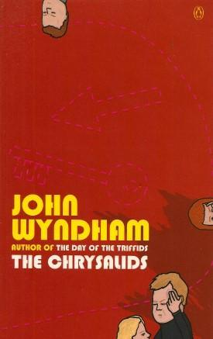
The Chrysalids
“How to remake modern civilizations”
Welcome to our new Novel Study Unit. We will be studying a novel by John Wyndham, an American sci-fi author from the mid 1950s that wrote a book about what society and civilization might look like long after some sort of cataclysmic event (Nuclear War). He wrote this novel to explore themes of Genetics, Exclusion, Evolution, Religion and Society. We will be studying this novel to achieve the following goals:

- Improve our Reading skills
- Understand context and inferences in writing better
- build our imagination and creativity skills
- learn what are the most important aspects to a better society

As we read through this novel, we will be keeping a READING JOURNAL. This journal will involve different tasks and writing prompts for every class. You will be expected to keep up with the reading each class, making sure stay in sync with the rest of the class.

As we read through the novel, we will be also having class discussions about the events, themes, characters, plot, symbols and literary devices. You will be expected to build a GLOSSARY of these new terms (with definitions) as part of your READING JOURNAL. At the end of the novel study, you will submit your reading journal for assessment to evaluate if you have achieved our 4 goals for this unit (see above).

For a final project for this novel study unit, you will build an OFFICIAL COMMUNITY PLAN for your own mini-village civilization. What are the most important aspects of our civilization? What is essential for us to have in our villages to survive together? What rules must be in place? You will create a 3 page plan (with map/layout) of your own village with your own OFFICIAL COMMUNITY PLAN to help guide your society/civilizations.

Some of the potential Writing Prompts for your READING JOURNAL:
- What super power would you want to develop in your future civilization?
- What challenges would your civilization face in order to succeed?
- What similiarities do you see between the world in the book and the world we live in today?

