English 12 : Short Story Assignment

Short stories describe change and/or crisis in the human or natural world Their strength lies in presenting interesting characters, settings, and situations, and in rendering “…small but significant truths about human nature and the meaning of the human experience…” or the natural world.

The Task: (1) choose an interesting short story
This is your opportunity to read and review a great short story! Choose any short story that interests you such as fantasy, humour, science fiction, historical, mystery, romance, horror, etc.). You must choose a Short Story on this first day and let me know what your short story will be.

(2) identify and describe story elements
Status
Quo
Next, read and summarize your story and note the key story elements such as conflict, character, setting and atmosphere, tone, and theme (the main idea). You will need to identify the key elements of the “Hero's Journey” from the video you watched in class *( http://ed.ted.com/lessons/what-makes-a-hero-matthew-winkler ) Describe why you chose this short story, and what you liked or disliked about the story.
Hero's
Journey
Call to
Adventure
Assistance
Departure
Trials
Approach
Crisis
Treasure
Result
Return
New
Life
Resolution
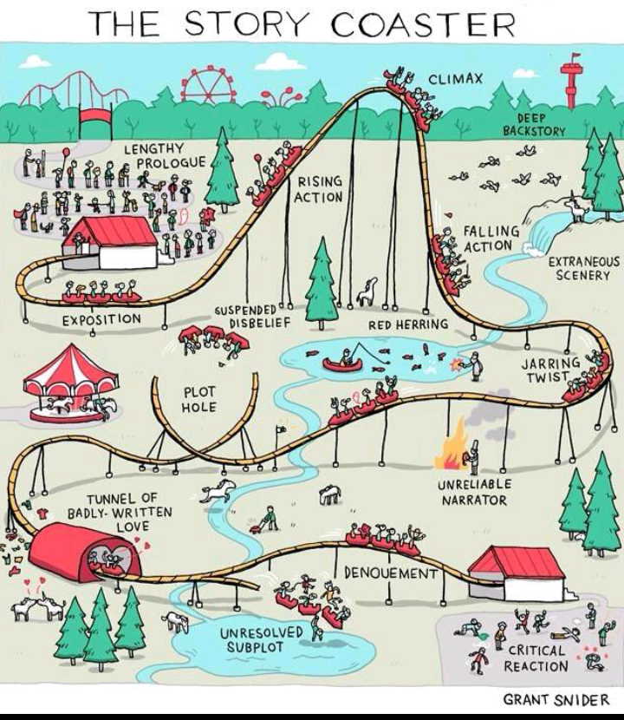

(3) connect the story to your life
Finally, explore how this story connects to you and your life – either in the past, present, or perhaps, your hopes for the future. What did this story make you think about?

(4) presentation
Create a short visual presentation to show the class which briefly describes your story and then sets out how your life and experiences connect to this story.

FINAL ASSIGNMENT:

1) Produce a short 5 min presentation about your short story: (8-10 Slides)
  - Who wrote it, When, What is it about?
  - What are the major elements of the short story ( conflict, character, setting and atmosphere, tone, and theme)
  - What elements of the “Hero's Journey” are present in your short story?
  - Why did you pick this short story?
  - What does this story mean to you, personally?
  - What did this short story teach you?
  - What are you taking away from this short story?
  - Why should your classmates read this short story?

2) Produce a 1 page handwritten summary of all the questions above that will be handed in for marks. Must be at least 300 words, and capture all the information from your presentation.

Marks Breakdown:

Presentation: 20 Marks
1 Page Hand in: 20 Marks

DUE: Monday, Jan 20th

