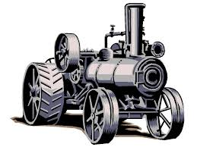
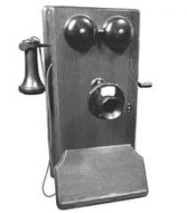
INDUSTRIAL REVOLUTION SMACK DOWN!

What is the most important invention we still use today from the Industrial Revolution?

Goal: As a class, we will figure out what is the most important!
First Step: Brainstorming 4 potential Inventions. You need to research them to learn: When they were invented, by whom, and what was their purpose?

Invention | Description/Inventor/Purpose
Step 2: You need to select the “MOST” important invention and begin to prepare a 1 page “Backgrounder” This “Background” page should have all the information you collected from Step 1, but also include more detailed description, an image, some links to websites about that invention and a paragraph that describes WHY you think it is the MOST important invention from the Industrial Revolution.

BACKGROUNDER:

- Date, Inventor, Description
- Purpose
- Image
- 3 links to websites
- Paragraph describing WHY it is the most important invention

SMACK DOWN:

As a class, we will all get up and describe our inventions and why they are the most important. Everyone will need to describe their invention and answer questions from the audience. After everyone's mini presentation, we will vote as a class as to the MOST important invention.



