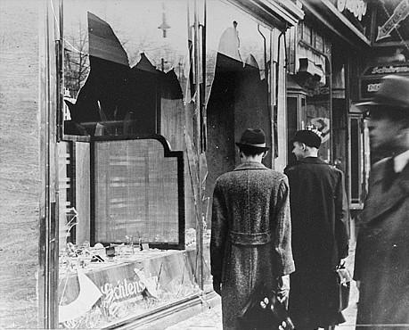
World War II

Social Studies 11 Research Project

Overview:

World War II lasted six years killing more people, destroying more property and disrupting more lives than any other war in history. The total number of military deaths is estimated at 17 million but many, many more civilians died from starvation, bombing raids, or massacres.

Learning Outcomes:
- Assess Canada’s role in WWII
- Assess the war’s impact on Canada

Individually, you will RESEARCH and ASSESS the events, impacts and significance of these war topics for Canada in the following 4 aspects: SOCIETY, IDENTITY, AUTONOMY, and INTERNATIONAL INVOLVEMENT .

Impact on the home front | Participation in Allied war effort
- Camp X  - Commonwealth Air Training centre (trained all the airmen for allies)  - Conscription Crisis  - Enemy Aliens (Germans, Italians)  - Japanese Internment in Canada  - Conscription  - Conditions on the home front  - Propaganda  - St. Louis Incident  - Women’s role in the war  - Mackenzie King | - Battle of the Atlantic  - Bomber command (raids over Germany)  - D-Day Invasion (Operation Overlord)  - Dieppe (tragic loss for Canadians)  - Fall of Hong Kong  - Italian Campaign including the Liberation of Rome and Battle of Ortona  - Liberation of Netherlands

There are 3 parts to this assignment:
1) Research
2) Notes
3) 1000 Word Essay

Research Process:
- Create some worthy research questions about your topic that explore the impacts on SOCIETY, IDENTITY, AUTONOMY, and INTERNATIONAL INVOLVEMENT of Canada through World War 2 and your specific topic
- Take notes from a variety of primary and secondary resources: photographs, personal accounts, books, websites, databases, encyclopedias
- Formulate a position. Find historical examples to support your position..
- Complete an essay outline that will be submitted with your research notes and final copy of the MLA formatted Essay

NOTES: 10 Marks

Your two column notes must be organized around Main Headings and supporting details and collect information and supportive evidence from at least 4 different TYPES of resources:
- Books
- Encyclopedias
- Websites
- Databases

ESSAY OUTLINE: 10 Marks
- Clear thesis
- Structural Outline for body paragraphs
- key evidence/quotes to use in essay

Essay: 20 marks

Your 1000 word MLA Style essay should have the following

Format and style
- Introduction with a clear position
- Supporting paragraphs (2-3) with historical examples, quotes, and references
- A conclusion that summarizes but also makes a final assessment
- Written in a style and at a level appropriate for grade 11
- A Works Cited page that references at least 4 different types of resources you used in writing this essay in MLA Format

Content
- Information demonstrates a depth of understanding and analysis of Canada’s role in WWII and the war’s impact on Canada
- Takes a position that is supported by relevant historical examples
World War II Research Pathfinder

SOCIETY
IDENTITY

ASSESS
Negative/Positive
impacts

Significance
*Changed
*Narrative//Story
International
Involvement
AUTONOMY

Researching AN EVENT? TRY USING…
- History encyclopedias and reference books (free photocopying)
- Dictionary of Canadian Military History (Ref 355 Ber)
- The Canadian Military Atlas Ref 355.409 Zue)
- Magill’s Guide to Military History (Ref 355 Mag)
- Horizon Canada (Ref 971 Hor) Use for Canadian information. Use index
- Canada at War and Peace Encyclopedias (Ref 971 Can) Use for Canadian battles
- Great Events (Ref 909.82 Gre)
- Purnell’s History of the 20th Century (Ref 909.82 Pur) Use index
- Illustrated World War II Encyclopedias (Ref 940.54 Ill) Use index.

GOOD INTERNET SOURCES
- Canadian Military History Gateway
http://www.cmhg.gc.ca/
- Canadian War Museum http://www.warmuseum.ca/cwm/exhibitions/chrono/1931crisis_e.shtml

